

**1** - Headphone-for personal use only, labeled in a Ziploc bag

**2** – 1-inch binders

**2** – boxes of pre-sharpened pencils

1 – pack of pink erasers

**4** – plastic two pocket prong folders (4 different colors)

**1** – box of crayons or colored pencils

**1** – box of thin Crayola markers

**1** – composition notebook

**1** – pack of expo markers

**Wish List for Donations:**

White copy paper

Personal mouse

Clorox wipes

Kleenex

Highlighters

Hand sanitizer

Colored copy paper

Hand soap

**We are looking forward to a stellar**

**2021-2022 school year!**

**Stone Lakes Eagles’ Always…**

**S** – Strive for academic excellence

**O** – Offer to help others

**A** – Act responsible at all times

**R** – Respect yourself and others

**Grades**

90 - 100% = A

80 - 89% = B

70 – 79% = C

60 – 69% = D

59% - below = F

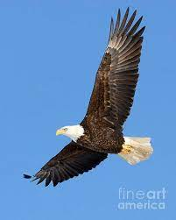



**Product/Service Information**

Exciting Field Trip

**Welcome to Fourth Grade!**

**Below are your 2021-2022**

**Fourth Grade Teams**

**Capen & Salemi**

**Foreman & Nickley**

**Kohrs & Soubasis**

**Stone Lakes Elementary School**

**Phone (407) 207-7793**

[**https://stonelakeses.ocps.net**](https://stonelakeses.ocps.net)



Curriculum Highlights

**Math:** Domains:

Operations and Algebraic Thinking, Number and Operations in Base Ten, Number and Operations in Fractions, Measurement and Data, and Geometry

**Science:** Body of Knowledge:

Nature of Science, Earth and Space Science, Physical Science, and Life Science

Curriculum Highlights

**English Language Arts (ELA):**

*Reading Literature and Reading Informational Standards* - Key Ideas and Details, Craft and Structure, Integration of Knowledge and Ideas

*Writing Standards* – Informative/Explanatory Writing in Response to Reading, Opinion Writing in Response to Reading

**Social Studies:** Florida history:

Some topics include: Primary and Secondary sources, Significant Individuals, Civics and Government

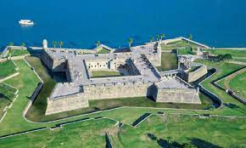

Join us on our annual field trip to St. Augustine as we explore the nation’s oldest city.

The field trip is curriculum based and designed to bring the vivid and exciting past of St. Augustine to life. Students visit a full range of historical and authentic sites including the Castillo de San Marcos. It’s a trip of a lifetime!